**Dissertation Topic: Twitter Sentiment Analysis on Supermarket Chains in the UK from 2020 to 2021**

1. **Introduction**

Natural Language Processing (NLP) is used in Twitter sentiment analysis to determine a person's mood and emotions from a text. Sentiment Analysis identifies if a user's tweet is favourable, negative, or neutral. Since a few days ago, social networking services such as Twitter, Facebook, Instagram, and YouTube have been extremely popular. They facilitate communication, the formation of networks, and the rapid dissemination of ideas. Twitter has become a fantastic platform for the formation and expression of opinions. Twitter Sentiment Analysis may be used for real-time business applications, which can be quite beneficial. It may be used for people's opinions on current political issues and Twitter trends.

As the audience on media platforms grows, data from these platforms may be used to analyse people's attitudes. By analysing the attitudes of the public, manufacturers and designers of consumer goods may evaluate their products. This is how individuals respond to their merchandise. Marketing staff may see how individuals respond to their adnvertising efforts. They can analyse the associated emotions.

There are many reasons why we chose Twitter data for sentiment analysis. Some of the reasons are given below.

- Twitter is used by a wide variety of people, including normal citizens, actors, politicians, businesspeople, and religious and social leaders, to share their opinions.

- More than 500 million tweets are posted every day on Twitter, which is an immense amount of data for sentiment analysis.

- Twitter users include everyday users, celebrities, corporate leaders, and political personalities. Twitter, therefore, represents the perspectives of all groups.

- Twitter is populated by people of various ages, including a significant proportion of businessmen. And individuals from several nations are represented on Twitter.

- The Twitter programme has been downloaded more than fifty million times and is utilised by many web browsers.

A common use of this technique is in the social media area, where it is used to determine how people feel about certain issues by analysing social media users' text messages or tweets in the context of Twitter.

This thesis analyses the attitudes of English tweets concerning two supermarket brands, Aldi and Morrisons, using machine learning techniques. The research was conducted in conjunction with Behavioural Science to determine if the company's market share is influenced by consumer feelings and, if so, which affects market share more within the specified time period. Specifically, to use machine learning tools like TextBlob or VADER (Value Aware Dictionary and Sentiment Reasoner) to figure out if certain tweets are good, bad, or neutral.

1. **Literature Review**
   1. **Sentiment Analysis algorithms**

Natural Language Processing is a subfield of Artificial Intelligence. This field aims to establish a link for interacting with humans using natural language. This type of intelligent system is constructed using computational and linguistic technologies, and it processes natural language similarly to humans. The NLP development process consists of the phases depicted in Figure 1???

The NLP development cycle begins with text collection. The collection of text is known as a corpus. Because not all text is processed, all text data is afterwards analysed. In addition, the procedure proceeds to the step of early processing. The objective of this step is to clean and pick the relevant text. Then, proceed to the phase of feature engineering. The objective of this phase is to extract characteristics from unstructured text. With the formation of features, the text becomes organised and ready for calculation to generate emotion. It can be determined using rule-based or machine learning methods. This research use lexicon-based rules.

VADER is a lexicon and rule-based analysis tool for sentiment. It is an open source created by George Berry, Ewan Klein, and Pier Paolo under the MIT licence. The Vader lexicon works very well in the sphere of social media. VADER preserves the advantages of conventional sentiment dictionaries such as LIWC (Linguistic Inquiry and Word Count). It is larger, readily examined, easily understood, rapidly implemented, and extensible. The VADER sentiment lexicon has been evaluated by people and is of gold-standard quality. VADER differentiates itself from LIWC by being sensitive to sentiment expressions in the context of social media and also generalising more favourably to other domains.

A sub-discipline of NLP whose goal is to decipher people's perspectives on certain subjects, events, etc. [???] [???]. It is known as opinion or sentiment analysis in text mining. This creates a large issue area. There are also a variety of titles and responsibilities, such as sentiment analysis, opinion extraction, opinion mining, sentiment mining, impact analysis, subjectivity analysis, mining review, etc.

[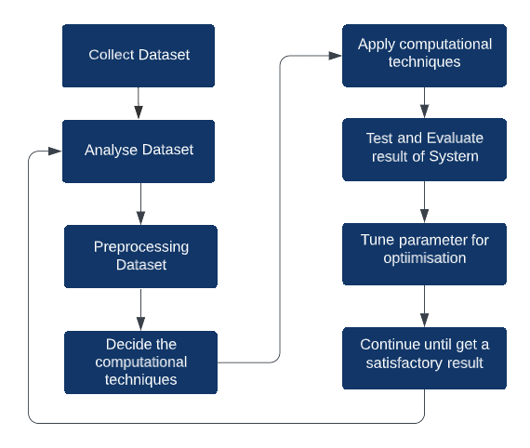 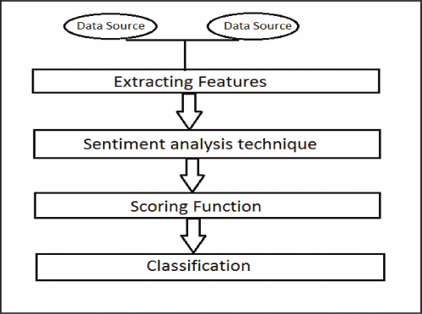](https://ieeexplore.ieee.org/mediastore_new/IEEE/content/media/8826088/8834451/8834477/012019069_Sentiment_Analysis-fig-1-source-large.gif)

**Fig. 1.**

Development cylce in NLP

The most important sentiment indicator is sentiment words. These are words that are commonly used to express positive or negative sentiments [???]. For example, good, beautiful, and amazing are words of positive sentiment; and bad, corrupt, and terrible are words of negative sentiment. Sentiment words are important for sentiment analysis for obvious reasons. A list of such words is called the sentiment lexicon (or opinion lexicon). Over the years, researchers have designed many algorithms to compile such lexicons. Although sentiment words are important for sentiment analysis, just using them is not enough. The problem is far more complex.

In the sentiment classification phase, there are several methods for classifying sentiments. These methods are shown in Figure ???3. This classification was initially divided into 2 approaches, namely machine learning and lexicon-based approaches. In this study more towards Lexicon which has been prepared dictionary base. This dictionary only contains adjectives that are collected and then have labels.

The following tasks are involved in the pre-processing task: • Deleting retweets (for twitter datasets) • Removing URLs, special characters, Punctuation, Numbers, etc. • Removing Stop words • Stemming • Tokenization. The word sentiment identification is an important job in many applications of sentiment analysis and opinion mining, such as mining tweets, discovery of opinion holders, and classification of tweets. Sentiment words can be classified into Positive, Negative and Neutral words.

* 1. **Related Work**

There have been several research works done on Twitter Sentiment mining to date. The work done by Sahar A. El Rahman (ElRahman2019) at Princess Nourah Bint Abdulrahman University, Saudi Arabia was done on Data was collected on two subjects McDonalds and KFC to show which restaurant is more popular. Various machine learning algorithms were used. Evaluation results from these models were tested using various experimental metrics such as cross-validation and f-scores. The model of El Rahman et al. finally showed good results with high accuracy efficiency. Give the answer that McDonalds is more popular than KFC in terms of both negative and positive reviews. However, the study only stops at the level of statistical evaluation of tweets sentiment and provides a predictive model that re-evaluates machine learning results. It's just a matter of statistics to know which topics are more popular, more positive reviews, not exploiting the deep quality aspect of tweets. As well as not analysing in terms of time period, to track the change in user emotions.

In this research paper (ikoro2018), the topic of sentiment analysis expressed on Twitter by UK energy consumers. They optimized the accuracy of sentiment analysis results by combining functions from two sentiment vocabularies. The results are impressive, but re-implementing this method takes a lot of work on a custom lexicon set. The thematic element of comparison between old energy supply enterprises and new start-ups is well worth learning.

Singh and Dubey showed the whole concept of sentiment analysis and opinion mining, especially data from social networks like Twitter. Both the concept, the methodology and the types of classification algorithms are fully covered. This shows that the importance of applying TSA to an appropriate topic should not be too broad.

Min Song et.al. (Song2014) employ temporal Latent Dirichlet Allocation (LDA) to analyze and validate the relationship between topics extracted from tweets and related events. They developed the term cooccurrence retrieval technique to trace chronologically cooccurring terms and thereby compensate for LDAs limitations. Finally, authors identify thematic coherence among users identified in sending receiving mentions.

\cite{NISAR2018101} and \cite{Das2018} suggested a method for mining Twitter data to anticipate the movements of a company's stock price based on public views. The authors also explain why the stock price of one company is more predictable than that of another. They propose using a data mining algorithm to determine whether the stock price movements of FTSE 100 or the NASDAQ can be predicted by 15 million tweet records (i.e., Twitter messages). They accomplished this by extracting ambiguous linguistic tweet data using NLP techniques to define public sentiment. Then, they used a data mining methodology to uncover similarities between public sentiment and actual stock price movements.

The Stock market is never an outdated topic, it is in fact constantly updated with improved algorithms such like in research by \cite{Hu2021} and \cite{Kanavos2020}.

There has been a lot of research to evaluate the technical aspect of machine learning technology on which algorithm model provides the best accurate results for NLP (Mandloi2020). Summarizing from the above studies, the following factors can be seen:

- Mainly they all have a strong focus on the technical side of Computer Science, more specifically Data Science.

- There are not many applications of Sentiment Analysis in popularity or business impact of enterprises.

- There are not many theories from the basis of behavioural analysis.

Therefore, this study will focus on the academic aspect, applying the advanced achievements from the above technical research papers to analyse in detail the results found from the sentiment analysis. . The research will evaluate the positive and negative comments according to the most popular keywords, and examine their influence on the market share factor of the business. It is also possible to view the top reviews of each category, to understand more specific extreme cases.

1. **Materials and Methodologies**
2. Market Share of Aldi and Morrisons

Statista source by Kantar World Panel

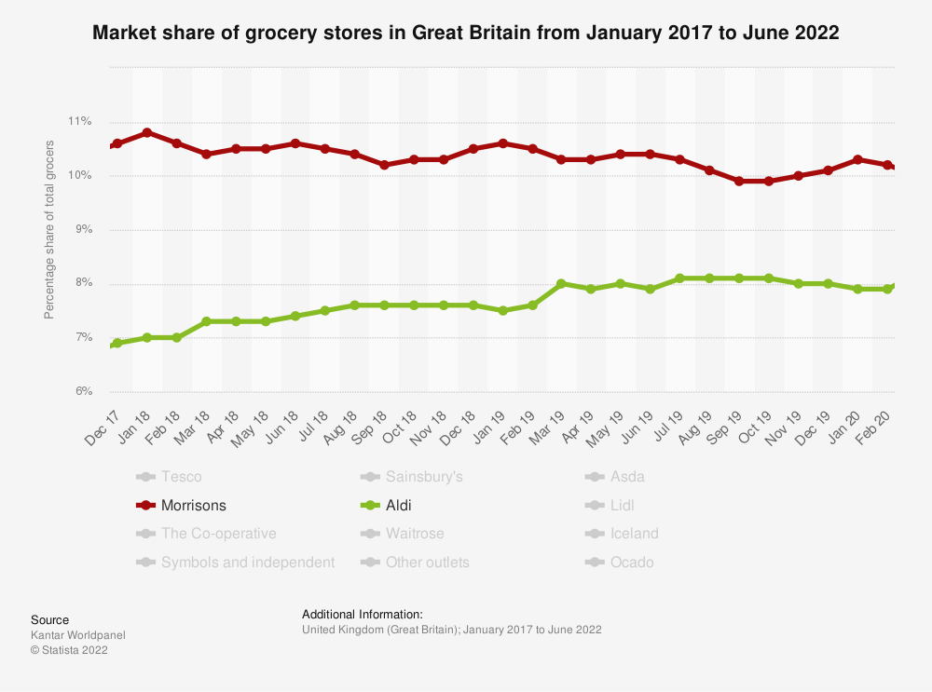

1. Data Mining

We use Python Twitter API [???] – Tweepy to search for public tweets that mention of either “Aldi” or “Morrisons”. The data is downloaded for two hours daily from December 01, 2021 till May 31, 2022 to capture JSON [???] objects that are being parsed to extract readable tweets and user information. The total number of tweets captured is about 12,000 during the time frame.

Figure 4 depicts the course of this study. Utilizing the Twitter API, a collection of tweets was used to acquire the data. The collected information is kept in the database as text. Next, do data analysis. The analysis of the data was descriptive. The analysis yields a list of adjectives together with hand labelling for use as a lexicon and in the creation of a system for sentiment analysis. In the construction phase of the system, the outcomes of this design are subsequently employed as the basis for a sentiment analysis of the structure. Next is the testing strategy step. In this technique, if a mistake occurs, it will be repeated throughout the building procedure. However, if there are no deficiencies, the discussion phase will commence.

In Figure 5. the flow of the sentiment analysis process is shown in getting sentiments towards tweets. The steps that can be passed can be described as follows:

### 1. Tweet Crawling

A user initially inputs the topic so that there are some tweets that match the topic. The topic was parsed through the Twitter API to the server so that some tweets that contained words according to the topic were obtained.

[[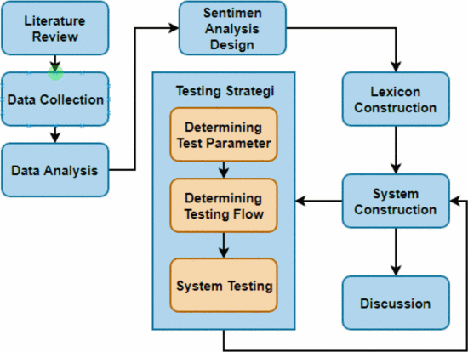](https://ieeexplore.ieee.org/mediastore_new/IEEE/content/media/8826088/8834451/8834477/012019069_Sentiment_Analysis-fig-4-source-large.gif)[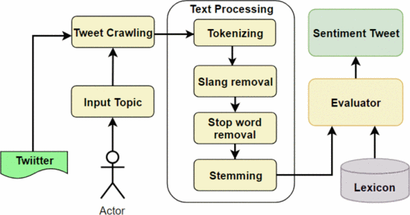](https://ieeexplore.ieee.org/mediastore_new/IEEE/content/media/8826088/8834451/8834477/012019069_Sentiment_Analysis-fig-5-source-large.gif)](https://ieeexplore.ieee.org/mediastore_new/IEEE/content/media/8826088/8834451/8834477/012019069_Sentiment_Analysis-fig-4-source-large.gif)

**Fig. 4.**

Research work flow

**Fig. 5.**

Sentiment analysis work flow

### Tokenizing

At this stage, the tweets obtained are broken down into separate words. Additionally, the punctuation and url address that appears when tweets are also deleted.

### Slang Removal

This stage attempts to replace words that have current terms (slang words) with standard words according to language rules. This change process is done by making a list of slang words and their synonyms on the database. Then, match the existing words with the list of slang words in the database. If it matches, it will be replaced with the synonym. If the word does not match, the word is omitted.

### Stop Word Removal

In a sentence there are several words that indicate that the meaning of the word is less meaningful. Stop word in this study has provided a stop word list on the Twitter API.

### Stemming

This stage aims to get the basic word on a tweet. The basic word is obtained using Porter Stemming which is in the Python library. This is done as a data reduction so that the processing of tweets is not too much data.

### Evaluator

This sentiment analysis has an evaluator feature. This feature is useful for retrieving data from Lexicon and matching it with the words tweet generated from the text processing stage. This evaluator produced several tweets that have been given sentiment polarity such as positive, negative, and neutral.

1. Methods [Sentiment Analysis: VADER or TextBlob?](https://towardsdatascience.com/sentiment-analysis-vader-or-textblob-ff25514ac540)

We hope to evaluate and use natural language processing methods and techniques by exploring the data. We do sentiment analysis using NLTK 2.0.4 powered text classification process. In social media data, user types in multiple punctuation marks, acronyms and an emoticon to express their sentiments. We are going to use NLTK's VADER analyser, which computationally identifies and categorizes text into three sentiments: positive, negative, or neutral. We make use of VADER, as it handles the data by including all sorts of letters, symbols etc. in its lexicon. In this approach, each of the words in the lexicon is rated as to whether it is positive or negative, and in many cases, how positive or negative. By this approach, we can analyse if the tweet expresses positive sentiment, negative sentiment or if it's neutral.

The maximum length of a Twitter message is 140 characters, thus the limited length of tweet, might comprise of one or two sentences. Thus our task is the simple breakdown of the tweet to extract the polarity from it. The data extracted from tweets downloaded from Twitter is in JSON format for exploratory analysis. We consider tweets, re-tweets and quoted tweets to capture the sentiments of people and businesses. We focus on the following parameters: Date, Location, Keywords, Positive polarity, Negative polarity and Neutral polarity. The extracted readable data is saved to csv files. These files are the data source for further analysing and creating data visualizations and reports through Seaborn library of Python.

1. **Results and Discussion**
2. **Data Structure**

There are 2 collections of Tweets for 2 years from Jan 2018 to Dec 2019, for keywords: “Aldi” and “Morrisons”. In specific, there are totals of 40,606 tweets about “Aldi” and 24,058 tweets about “Morrisons”. The Dataset of each chain then divided into 2 smaller sets, accordingly to the semi-annual from Jan 2018 to Jun 2018, Jul 2018 to Dec 2018, for the purpose of finding the underlying TSA metric. From there, compare with specific time periods corresponding to the ups and downs of market share in 2019.

The collected data then being performed through ETL process, data cleaning, data processing for NLP. The dataset then being processed for sentiment analysis with the VADER algorithm. The data set for 2 years will be divided for analysis as follows: the first year will be used for semi-annual analysis. From there it is possible to have baseline data, which will form the basis for special analysis in the following year. In the second year, only special periods will be selected to analyse and measure the effectiveness of TSA application. The results are as following.

1. **Results**
   * + 1. **For Aldi**

The market share for Aldi witnessed an upward trending throughout the 2 years period. In more detail, the market share growing in the first 6 months and staying flat for the last half of both years. Overall, Aldi did a great job, especially during 1st Quarter 2019, growing from 7.5% to 8%. Below is the sentiment analysis in semi-annual of Aldi and then a separate analysis for the first quarter of 2019.

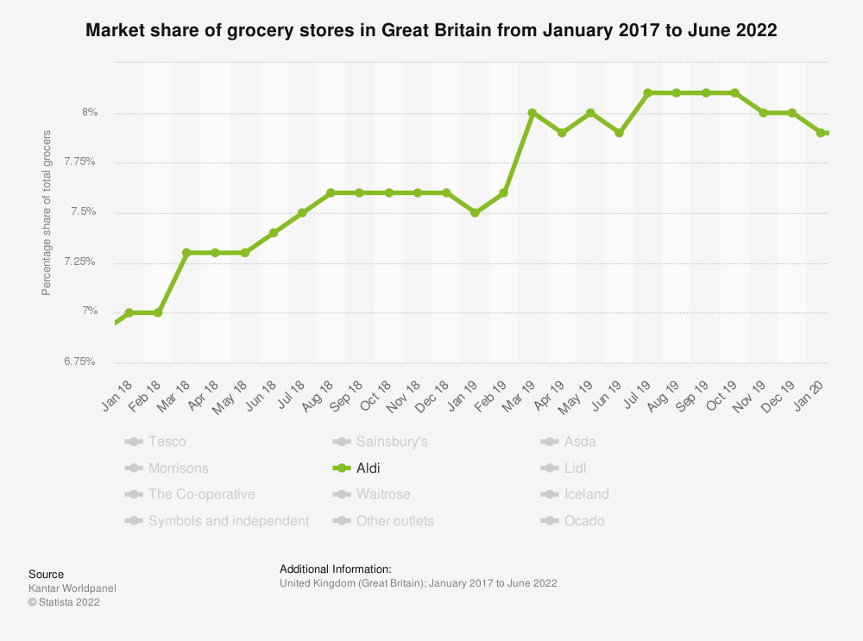

The number of different types of Tweets about Aldi in year 2018 and 2019. Look at these graphs, it can be easily seen that throughout both 2018 and 2019, the most positive tweets received are in 3 consecutive months namely November, December, and January respectively. It can be said that the number of negative tweets is also witnessed a similar pattern, where the total number of tweets received increased proportionally to the increase in the number of both positive and negative tweets received. For more clarity, let's take a look at the chart above in form of percentage between the types of Tweets.

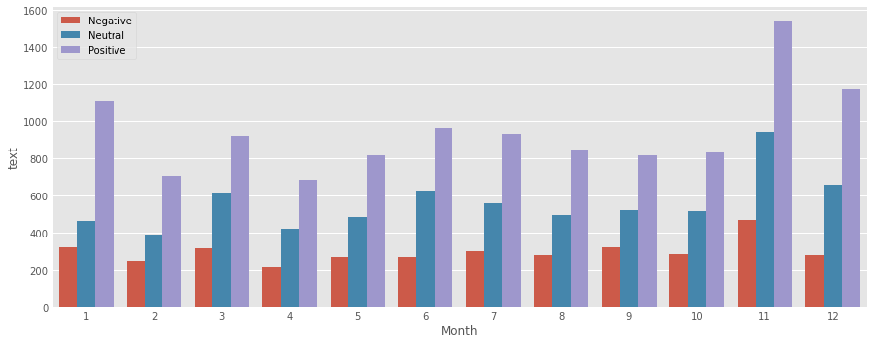

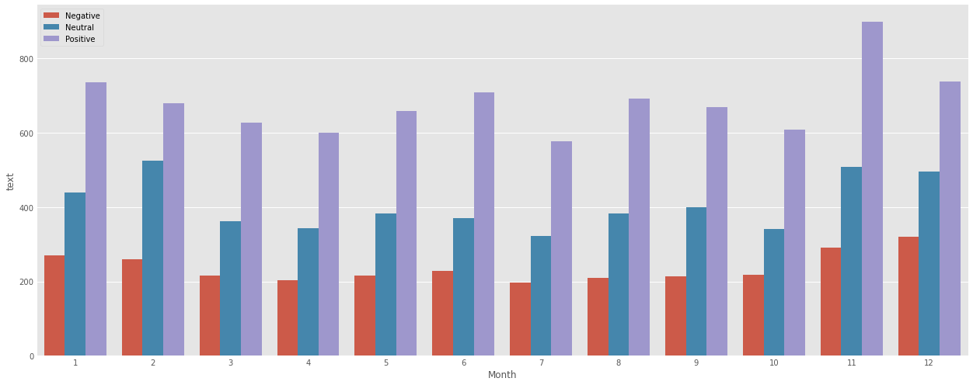

Indeed, when converted to percentages, there was a difference between the two years. In 2018, January was the month with the highest rate of positive reviews of the year, corresponding to that December was the month with the lowest rate of negative reviews of the year. Broadly, Aldi’s assessment in 2018 began to turn well from October, when the positive rate increased while the negative rate decreased.

Whole year 2018 in percentage:

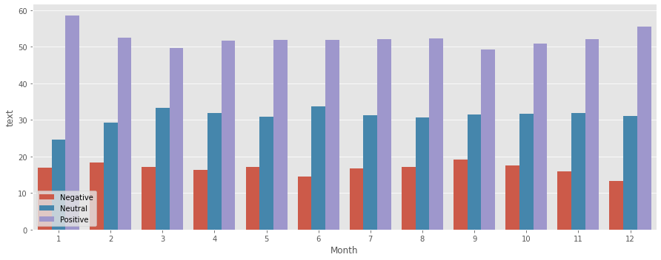

As for 2019, the transition between positive and negative rates changes continuously. From March to June is maintaining stable, then from September to December the situation worsens. It is December that had the highest negative rate of the year, with the second lowest positive rate of the year.

Whole year 2019 in percentage:

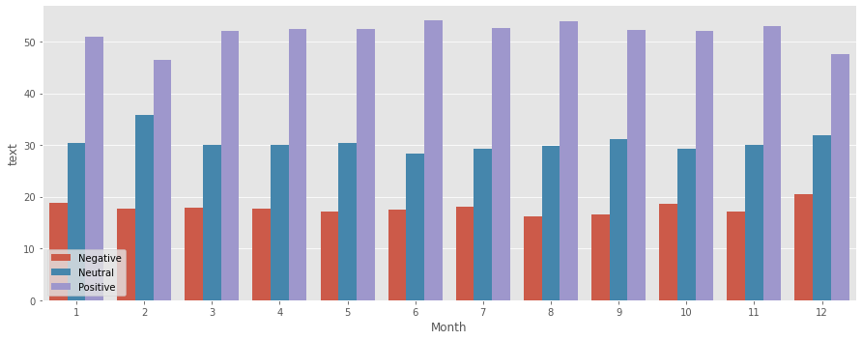

Summarizing both 2018 and 2019 according to the analysis of the quantity and percentage of tweets received. It can be temporarily seen that for the Aldi supermarket chain, the delay effect will approximately about 1 month, after receiving negative reviews, it will affect business results more or less, thereby affecting the market share of the enterprise. The following will be specific keyword analysis by using NLP VADER algorithm, from which to see what specific problems the Aldi chain is facing, or as well as the good points that Aldi is being praised.

* + - * 1. From Jan 2018 to Jun 2018

The results of sentiment analysis for Aldi in first half 2018: There are total of 10,673 tweets. In detail, Positive tweets accounted for majority as 52.8%, Neutral at 30.5% and Negative with 16.6%.

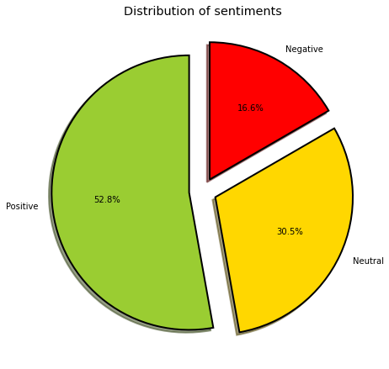

The graph shows most frequent words in positive tweets about Aldi in first half 2018. The keywords in the picture, combined with a rate of 52.8%, reflect that Aldi is favoured by consumers.

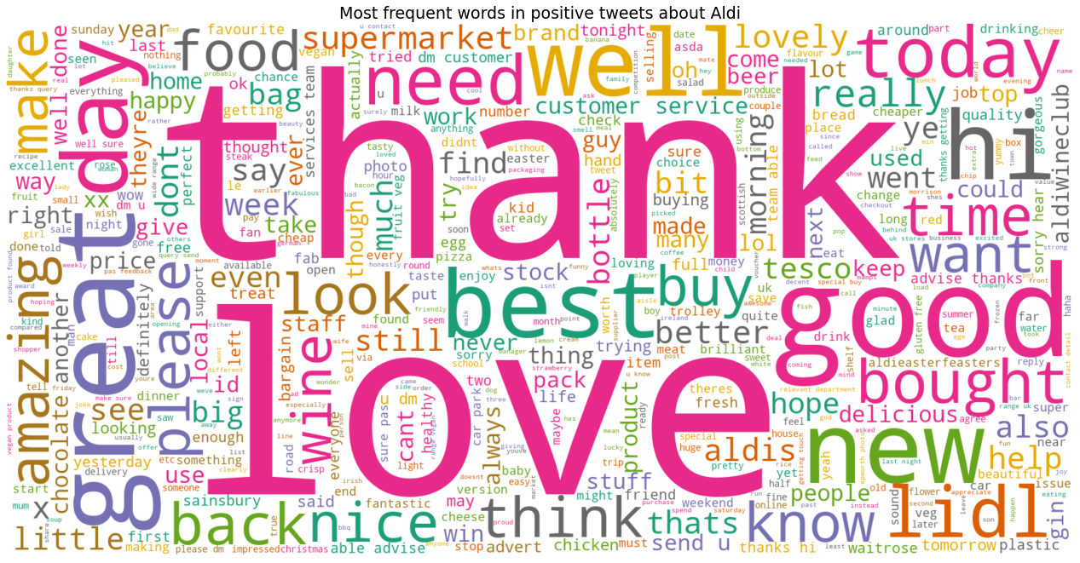

The top 10 of the highest score for positive tweets are as follow:

1 . would like wish everyone attending youth citizenship awards tomorrow best luck hope everyone enjoys experience congratulations everyone creating inspiring projectsthanks aldiforoigeawards weareforoige byc

2 . speed control excellent reversing excellent attention vehicle excellent position road excellent hill start excellent knocking pedestrian outside aldinot excellent excellent

3 . thanks show discus savvy summer supermarket wine best time huge thanks awesome supplier awesome selection showed beautifully thirstythursday wine

4 . aldi everything better honestly best orange juice best grape best yoghurt best crisp

5 . love local aldi amp would love voucher care home prize fun resident easter egg hunt delicious easter baking aldieasterfeasters

6 . buy gluten free dairy free fat free easily buy plastic free believe people deserve option go plastic free 2018 help

7 . help raise 400 help gloucester feed hungry continue support homeless need please donate rt thanks please retweet share love

8 . id love chance win wonderful giveaway hope ive right hugs artyju xx

9 . sharethealdilove love aldi always great choice product amazing value staff awesome

10 . hope proud absolutely love model used wks magazine reading outfits fav little syndrome girl shes beautiful amp show diverse company well done aldi

The graph shows most frequent words in negative tweets about Aldi in first half 2018. The keywords in this picture that are related to “time”, “plastic bag”, “back”, “today” and couples of adjectives like “disappointed”, “bad”. Also, the customers clearly compare Aldi to Lidl a lot. The top 10 most negative tweets are as follow:

1 . lol coke van still calls doesnt funny similar supermarket havent done symptomatic tesco gradually losing plot market share youll never beat aldi dropping lines

2 . lol coke van still calls doesnt funny similar supermarket havent done symptomatic tesco gradually losing plot market share youll never beat aldi dropping lines

3 . bloke wont stop sitting doorway belonging stuffed aldi bag begging money people walk past stop fucking life man couldhavebeengreat waste wba

4 . apart instant coffee bread lack disinfect cant fault aldi

5 . thats happens january shop aldi invest properly goal wouldnt matter

6 . aldi ham trimming worth trip alone

7 . hats aldi amp lidl closing new year day greedy big 4 however think market share rather staff amp families disgraceful

8 . suffer full works last weekend well people go thurs fri wirral go manage aldi mum like rest u leave pjs rough rest u

9 . last night successful auction getting drowned blown away exeter pitch auction swindon aldi 9am 500 pitches start bidding 999

10 . well done think getting mine till start stop putting layer cellophane fruit skin already

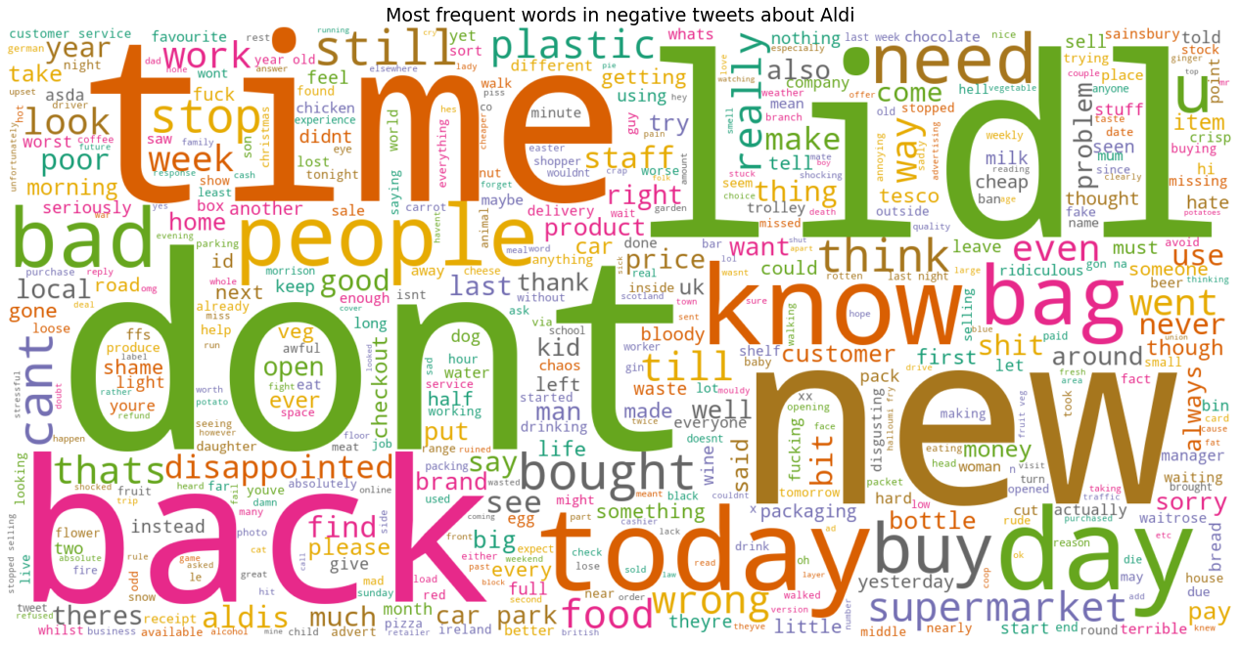

And among the neutral comments about Aldi, the keyword content is also mostly negative, but perhaps less negatively oriented.

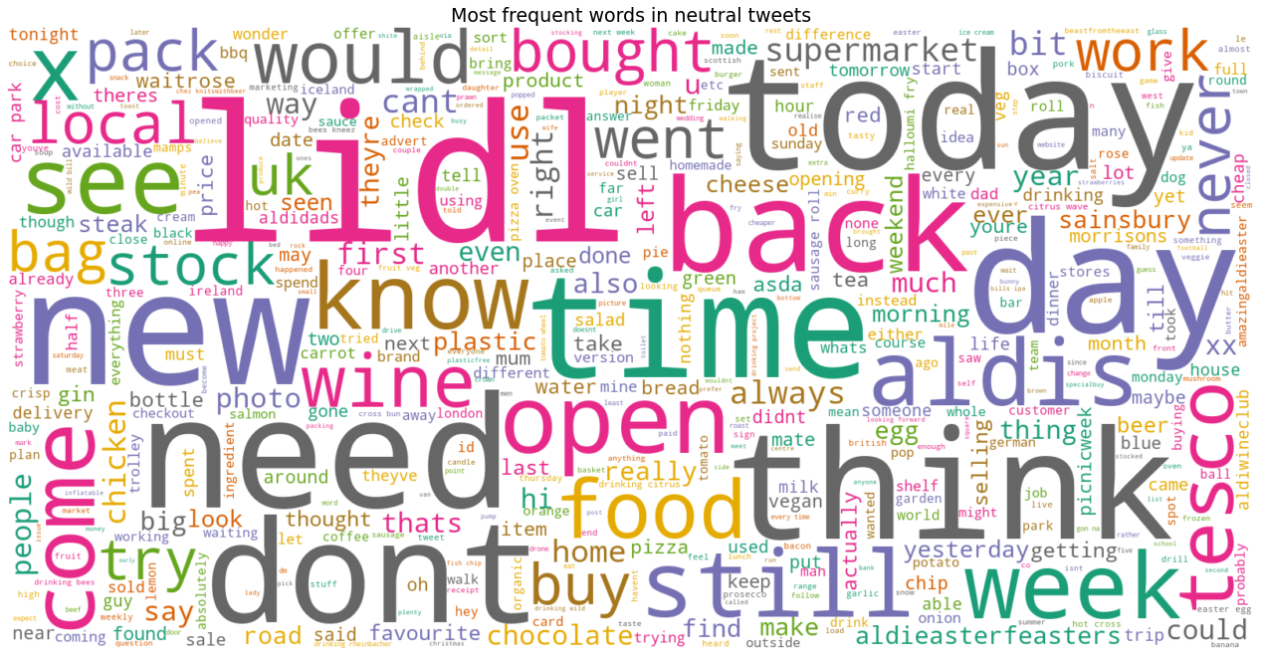

* 1. From Jul 2018 to Dec 2018

The results of sentiment analysis for Aldi in last half of 2018: There are total of 12,775 tweets. In detail, Positive tweets accounted for majority as 47%, Neutral at 37.3% and Negative with 15.8%.

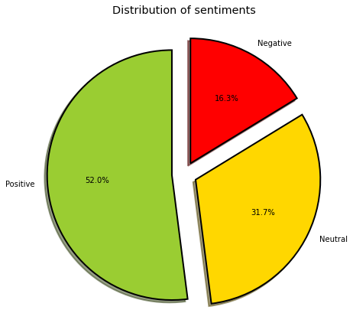

This can partly explain why the market share stay flat: Although the rate of positive comments decreased, but it is worth noticing that during this time period that Aldi has reduced the rate of negative comments to as low as 16.3%. Top 10 positive tweets:

1 . love actually liked following happily retweeted thanks giving opportunity win great prize

2 . wow lovely hope lucky thanks chance good luck everyone ive happily retweeted

3 . would love win amazing prize love baking nice treat child especially christmas

4 . liked following happily retweeted thanks giving opportunity win great prize

5 . win bank holiday oh wow thank much great prize retweeted win giveaway

6 . im liking rtampf chance win lovely luxury christmas assortment friday id moon amp around sun amp straight local aldi store super lucky winner

7 . great night yesterday women business 2018 supporting excellent speakers lovely high tea excited win raffle networking cwmbran charity ilovealdi

8 . love good firework party though always save spare new years eve note found gorgeous puglian demisec sparkle ognissole blum holiday really hard outside italy advice like bubble also sweetish tooth aldiwineclub

9 . love chain proud using free range irish chicken creating first market product taste amazing give customer health benefit authentic bone broth even award year

10 . win parents theyve high low life supporting throughout kind generous happy giving love without question

Look at the most frequent words in all tweets, there seems Aldi had done good on the Christmas Eve, everyone mentioned about keyword “Christmas” despite it is a positive or a negative comment. And people mentioned “Kevin the Carrot” quite a lot, that appears a success marketing campaign. Among the top 10 most positive comments, mostly all mentioned a certain contest, and winning the prize. This contest has clearly reached a lot of people, bringing positive emotions spreading the message #iloveAldi on Twitter.

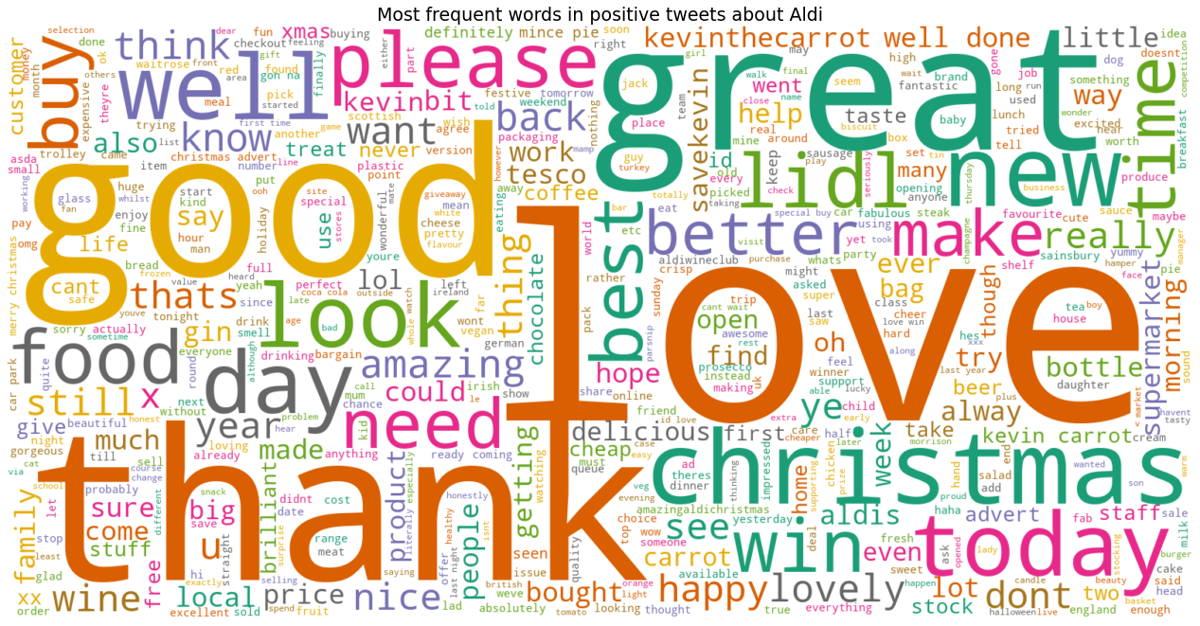

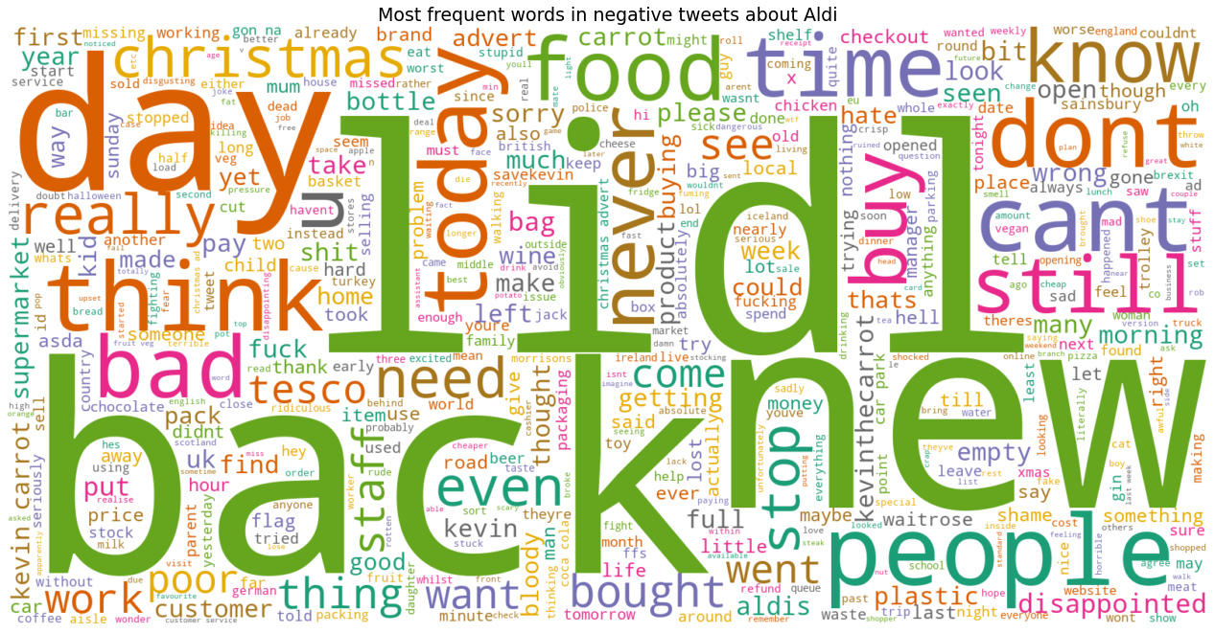

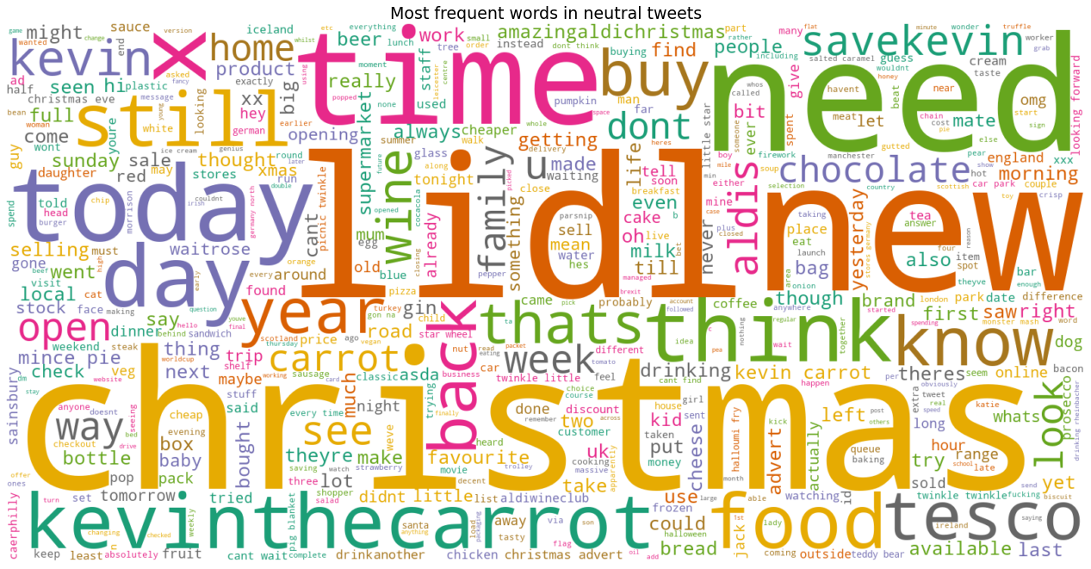

* 1. From Jan 2019 to Mar 2019

The results of sentiment analysis for Aldi in first quarter of 2019: There are total of 7,075 tweets. In detail, Positive tweets accounted for majority as 52.8%, Negative with 15.6% and the rest are Neutral.

This period witnessed a high growth for Aldi’s market share. Which has appeared highest rate in the positive and lowest rate in negative tweets at the same time compared to last year’s figures. This record low negative rate maybe the reason why Aldi’s market share has that amazingly growth.

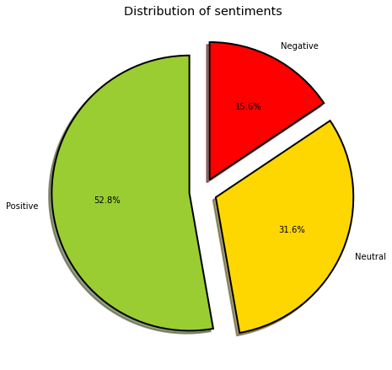

All the keywords are also related to the successful Christmas Business Eve. This indicate to all other business operations that Christmas is the biggest event in the year. Therefore, they should be well prepared for their endeavour.

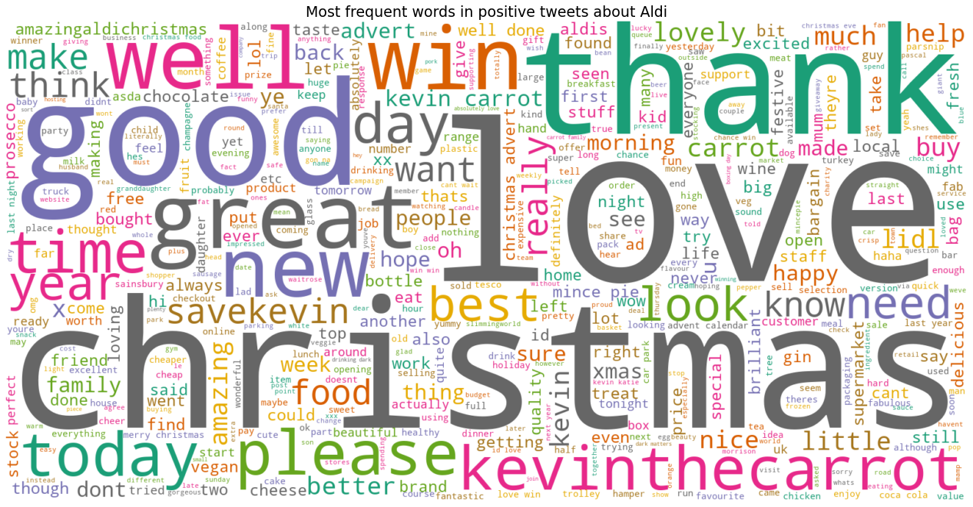

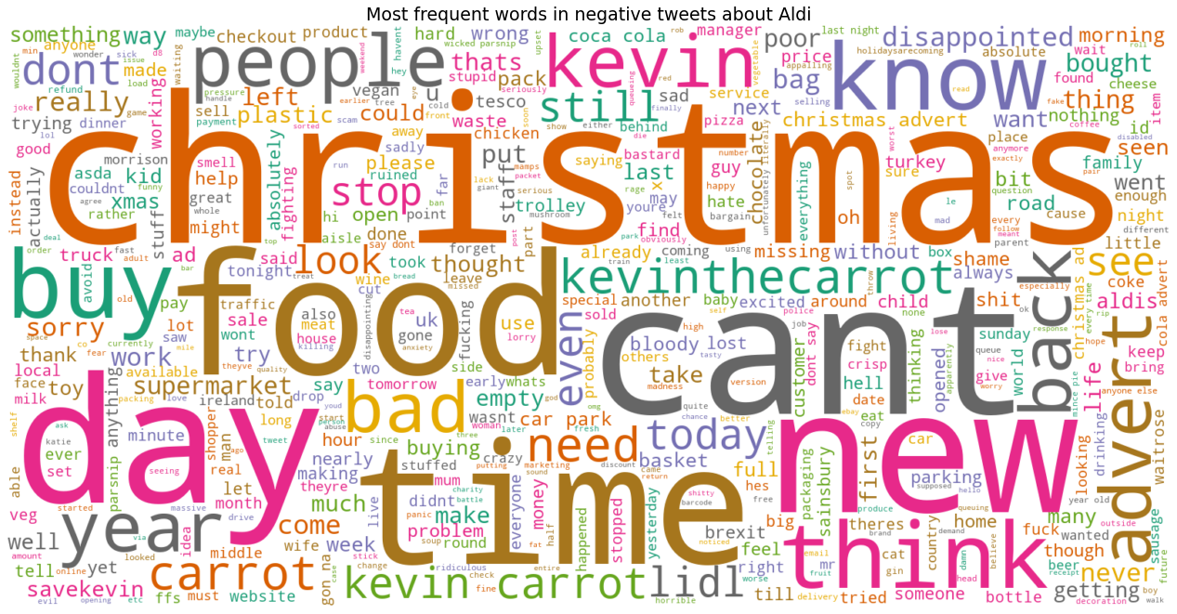

* 1. 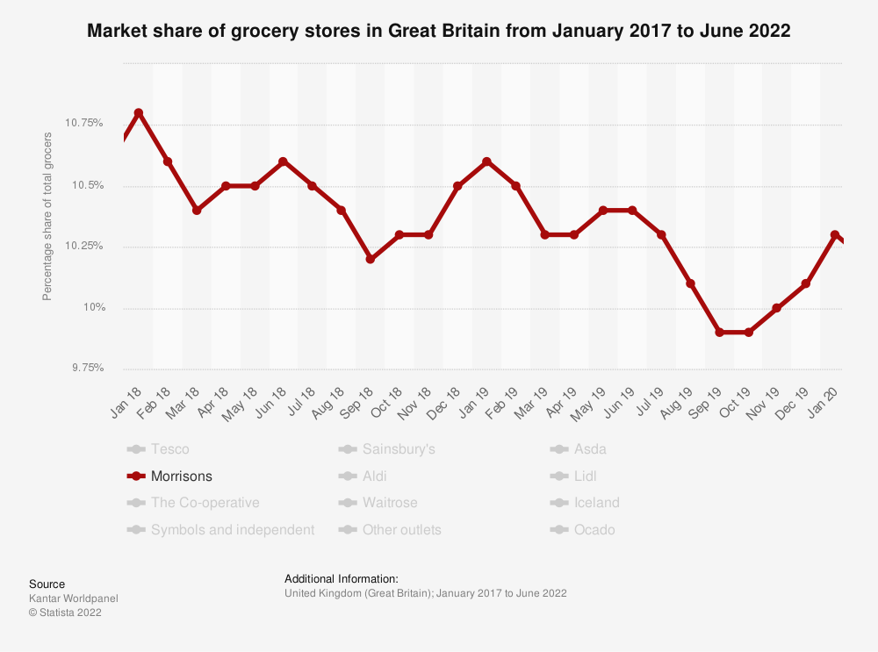**For Morrisons**

This period witnessed the downtrend in market share for Morrisons from 10.8% in Jan 2018 to 10.1% in Dec 2019, with the plummet period in Sep to Nov 2019 with 9.9%.

Looking more closely at the chart, Morrisons' market share has tended to drop at the end of Q1 and Q3, specifically March - end of Q1, September - end of Q3. This seasonal pattern has been repeated in 2 years from 2018 to 2019. That is the reason this research will pay more attention to the period in May 2019 to Dec 2019, after process the 2018 year for basic sentiments’ figures.

From the statistical graphs of total tweets’ sentiment for the whole year 2018 and 2019. In 2018, the Morrisons supermarket chain received the most positive comments in March, December, and Jun, while November and December were the two months receiving the most and second most negative comments, respectively. On the other hand, September and August were the months receiving the least positive comments, and interestingly the same pattern showed for negative comments. In 2019, Morrisons received the most positive and negative comments in November and December, and interestingly that the most negative 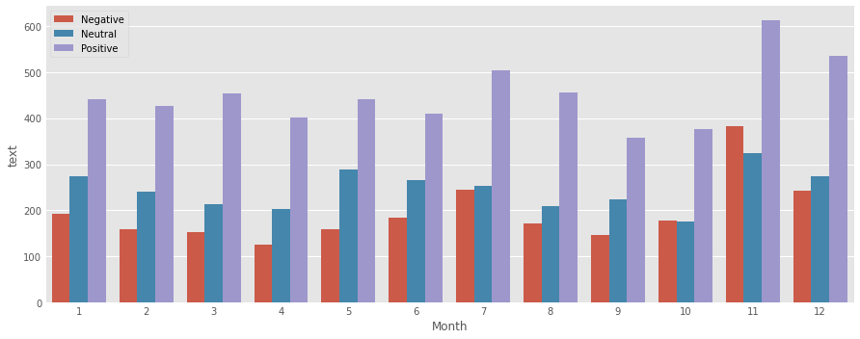comments were also received in November and December.

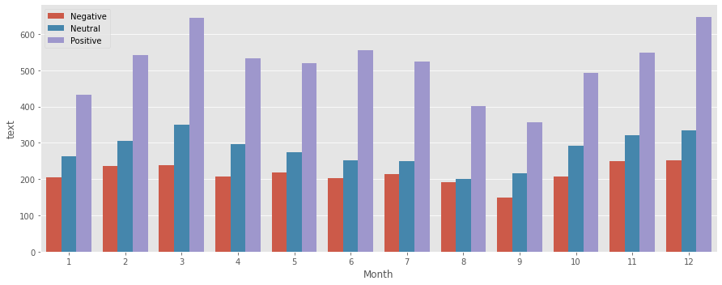

As present in percentage figures, in 2018: the months that received the most positive comments were June, July and December respectively. The months that received the most negative comments were August, January, and November respectively. Also, the months with the fewest negative comments were March, April and June. The fewest positive months were January, November and September. Although the effect of tweets is not so obvious in the case of supermarket chain Morrisons, it can be seen that August was the worst month of all of 2018 due to the lowest positive / negative ratio, this is also the lowest positive / negative ratio. at the same time, the month witnessed the most severe decline with a 1-month lag effect, when September hit the bottom of the market share of the whole of 2018.

In 2019: the months that receive the most positive comments are March, April and August respectively. The months that receive the most negative comments were November, July, and October respectively. Also, the months receiving the least negative comments are April, May and March. The best months of 2019 were March and April, and the worst were November according to the positive/negative ratio. From here, it can be summed up that the delay effect of the Morrisons supermarket chain is about 1-2 months. What is unusual here is that, in the fourth quarter of 2019, Morrisons' Twitter performance was relatively bad (with November being the worst month of the year) yet Morrisons market share went up through the end of the year.

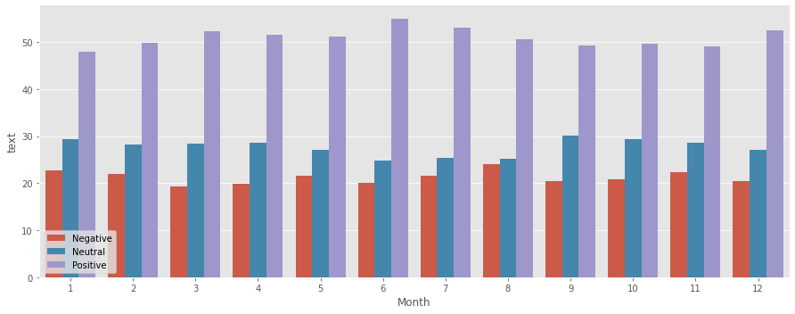

2019:

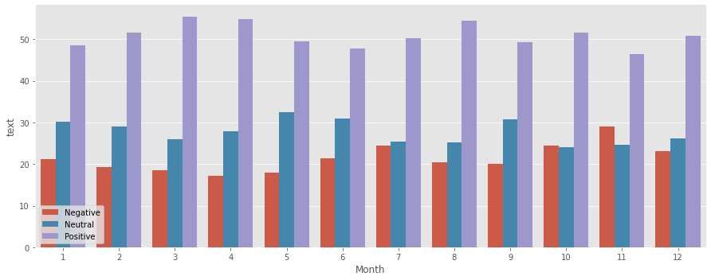

* + - * 1. From Jan 2018 to Jun 2018

This period saw a drop in market share from 10.8% to 10.6% with the lowest point as 10.4% in March 2018. Out of a total of 6,623 tweets, 51.4% are positive, 20.8% are negative and the rest are neutral. This is quite a reflection of Morrisons' market share performance. These sentiment indicators have clearly been worse than the same period of Aldi’s. People mentioned to Morrisons less than Aldi’s and so did their positive tweets.

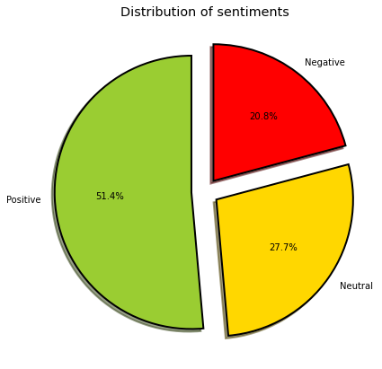

The most frequent words in positive are pretty much same with Aldi’s, the top 10 most positive tweets are as follow:

1 . yea lot good stuff underage next level huge step hopeful though think like saf important career football ideally united le like morrison cleverly giving youth chance best stay

2 . yay hard work great product amp branding moved full morrisons approval ready stocking new store abergavenny 9 product listed 1 follow great excitement amp thanks charlotte hill daughter great presentation

3 . thanks everyone sas lovely surprise amp kind words meant lot today definitely caught guard real pleasure work great bunch people luck dean

4 . watched happy yet syfy tv show based grant morrisons comic book personally loved witty fun wonderfully weird acting fantastic havent really catch keep great work

5 . thanks great feedback customer today newlandsfieldthe boy represented club well great day thanks much kind donation friendly staff engaging kid visit

6 . tomorrow 2pm pantibars famous free allday pride street party entrance party jervis st end great stand st behind morrison hotel free event number strictly capped happy pride

7 . hope nobody receives wonderful offer diabeticoooops glad see youre hope speak soon hope well xx great weekend nephew 28 today 565 today halfbirthdayborn december 30th lol

8 . small producer cornwall make u happy hear daughter love bars thank supporting us good luck competition win

9 . hi becki lovely tweet love hearing love tasty bars good luck competition win

10 . thanks preston park best staff customers giving generously also took home delicious steak pie tea thanks britishpieweek bonus

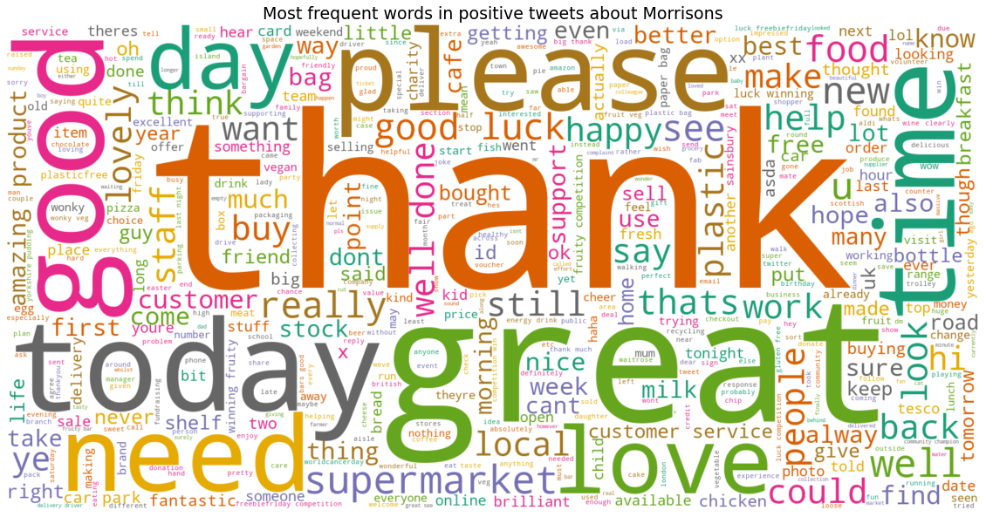

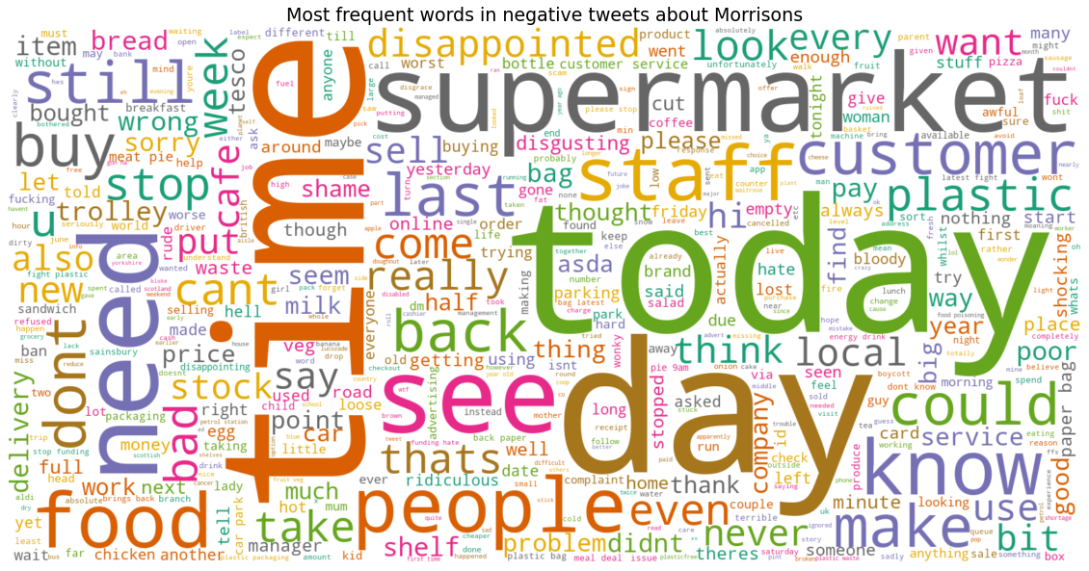

Among the negative comments about Morrisons in the first half of 2018, most notably keywords related to: time, day, people, staff. Customers clearly care more about their time shopping at Morrisons than they do at Aldi. And conversely, the quality of Morrisons' "food" product seems to be much less objectionable than Aldi's. The top 10 most negative tweets are as follow:

1 . ok busy cafe gamston dont appreciate lunch customer debris staff

2 . kay crazy lady cant starving

3 . common practice among supermarket varying price points dont matter morrisons even afonentioned

4 . really disappointed tonight took tupperware deli counter buy package free way staff could use wrapping purchase plastic sheets putting tupperware paper bag cant

5 . could please confirm new anpr parking charge system rossonwye affect entering buy fuel expecting u buy parking ticket different info various local source warning store shopped last week

6 . sneaky substitute 1 item drop 80 miss 8000pts bonus hello

7 . radio morrisons radio costcutter sure crazy fool thought good idea

8 . experience strong sale spite rising ingredient cost

9 . really staff told u updating prices upwards course sign power failure case staff advising customer customer care

10 . market street apple doughnut honestly say poor tonight little dribble apple inside whereistheapple 2 10

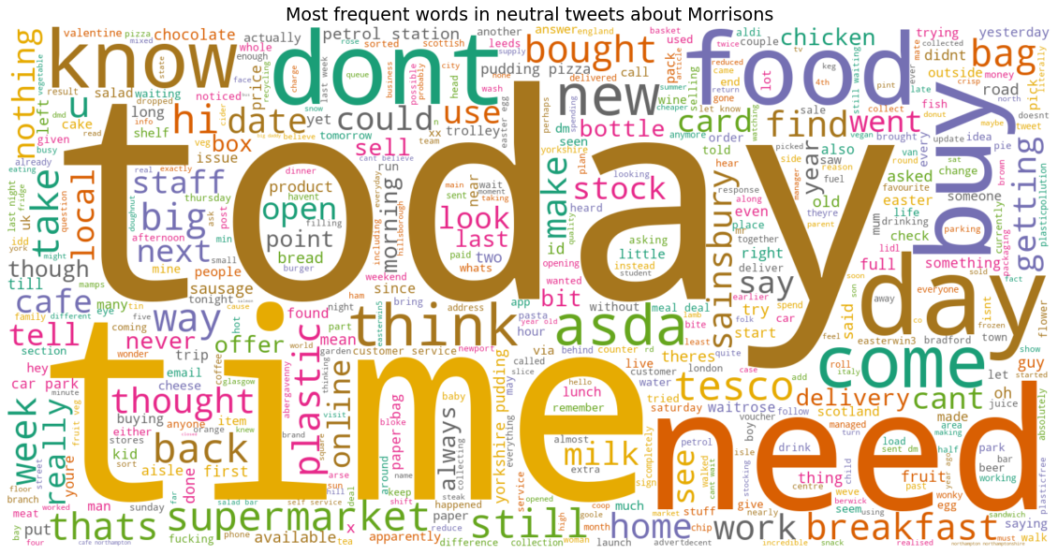

* + - * 1. From Jul 2018 to Dec 2018

From July 2018 to December 2018 was a rebound in Morrisons market share that remained flat at 10.5% at both ends, with the line concave the most in September at 10.2%. Among 6,216 tweets, there are 50.7% positive, 21.4% negative and the rest are neutral.

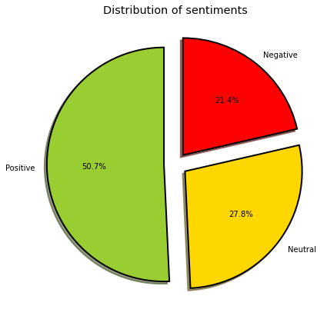 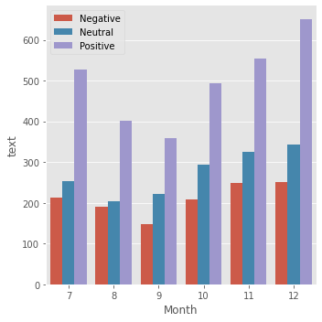

During the same period half year, when Aldi's Christmas campaign was so effective, that many people mentioned the theme of Christmas in a positive spirit, it was not so with Morrisons. The top 10 most positive tweets are as followed:

1 . guy anything like customer service award please consider delivery driver sean nash enfield far cheerful helpful friendly delivery remember great advert company cheered weekend top man

2 . bar perfect lunch box dont add cane sugar deliciously fruity bars thank entering comp great tweet good luck hope amazing bankholidayweekend

3 . huge thanks welcoming staff generous customer lindsayfield east kilbride super time bagpacking thanks much opportunity raise vital fund brave young patient

4 . yes danai community champ stamfordhill shes absolutely brilliant enthusiasm amp passion helping community utterly inspiring amp infectious donation box store far successful c100150 packet period product month

5 . lovely hear son love bars special offer moment waitroes ocado thank entering giveaway best luck winning

6 . kiddies love extra fruity tasting bars thank entering comp great tweet good luck hope amazing bankholidayweekend

7 . fabulous hope family well enjoying sunshine getting ready new season great summer

8 . brilliant day thanks knowledge passion enthusiasm thanks people morecambe welcoming interested

9 . would like say thank everyone eastbourne store making christmas collection easy amp stress free great service wishing everyone eastbourne shop merry christmas enjoy deserve

10 . spent lot time abergavenny last 24hrs due key locked car staff amazing warm funny kind welcoming thank wales drink store little bar brilliant cafe christmas

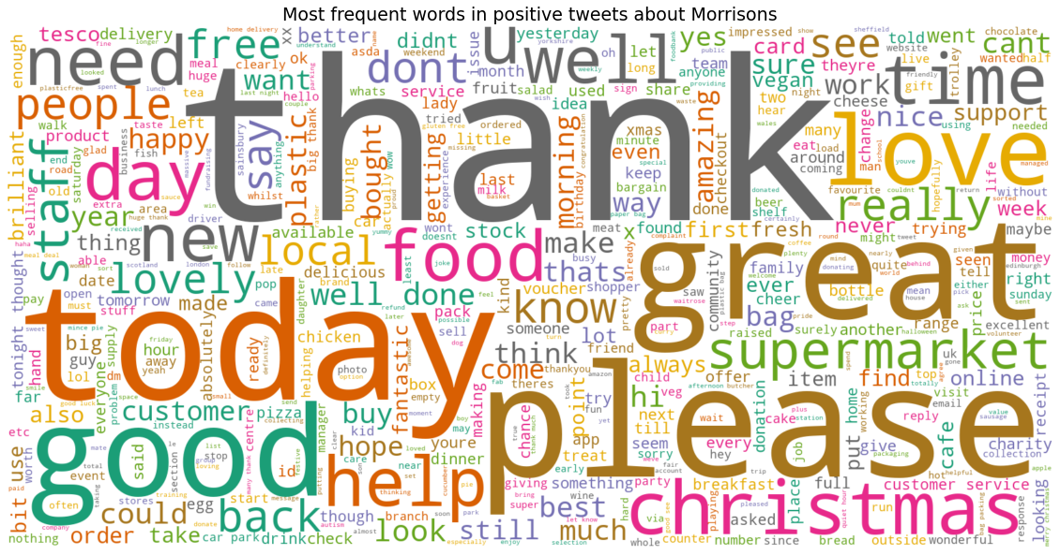

About most common words in negative tweets, the most commented topic remains the same like the first half of the year: time, plastic, food. The top 10 most negative tweets are as followed:

1 . appreciate really poor supermarket honest tired frustrated trying shopping go asda need every time bit away worth thank getting back

2 . ive never problem 4 hour bbbiiiiggg delay

3 . oh god morrisons shall lunch dont know please choose something immediately leave

4 . yep mind paying chilliesit thought wonky veg meant cheaper option odd

5 . sorted thank embarrassing time

6 . thanks sue xx unexpected went groceries hopeless

7 . hello purchased lighter mature cheddar 350g bag today opened block miniscule weighing 265g

8 . good food deal used work supplier produced mns amp morrison cheap crap went morrisons stuff guess u pay

9 . oh dear morrisons ipswich wifi first world problem

10 . looooool bet cancelled health kick straight away

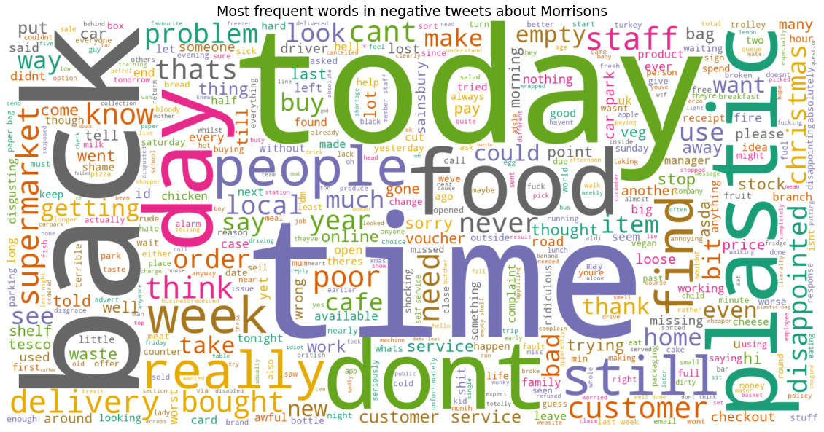

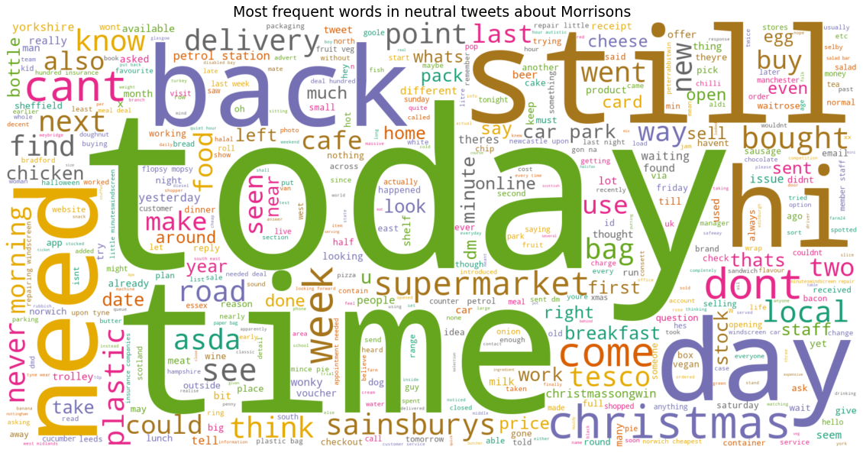

Overall, Morrisons had no improvement in service quality, customer complaints throughout the year remained the same, as other competitors were slowly taking over the market. It is worth noting that, in all three categories positive, negative or neutral, there is the appearance of keyword "today", which proves that users, regardless of opinion, will tweet on the same day that they go shopping.

* + - * 1. From Jun 2019 to Sep 2019

During this time, Morrisons' market share dropped dramatically from 10.4% to 9.9%. User reviews showed a high negative review rate at 21.3%, while positive had record low at 49%. This has also accumulated in the past when keywords showing negative reviews were still on familiar topics, this time the most frequent was “plastic”. The top 10 most negative tweets are as follow:

1 . would really appreciate reply find unacceptable

2 . im beginning realise ive online shopping year never shopped store must clear voucher fraudulently used yet dont care

3 . quite distressing watch clearly enough done supermarket consumer rely ball court reduce plastic waronplastic

4 . hi nope replying people hoping acceptable response shortly

5 . absolutely ridiculous need correct labelling amp customer service wouldnt serve bottle grenadine id bottle clearly stated front non alcoholic

6 . else ordered 500g frozen melon ball selection latest shop chilling decadently mwahahaha moi absolute puppy private folks

7 . make pizza decided get stood 5mins waiting told pizza short staffed went late stopped clean next time ill go straight

8 . going years im sure someones house alarm police would involved

9 . embarrassing thing scots like seem think plastering ujs scottish produce sensible get knee

10 . looks like emergency appeal working donation point bursting

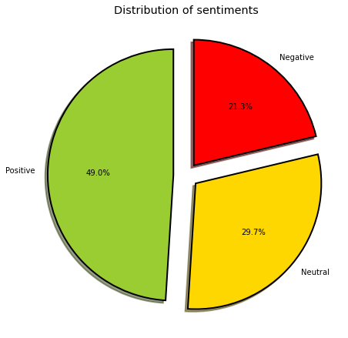

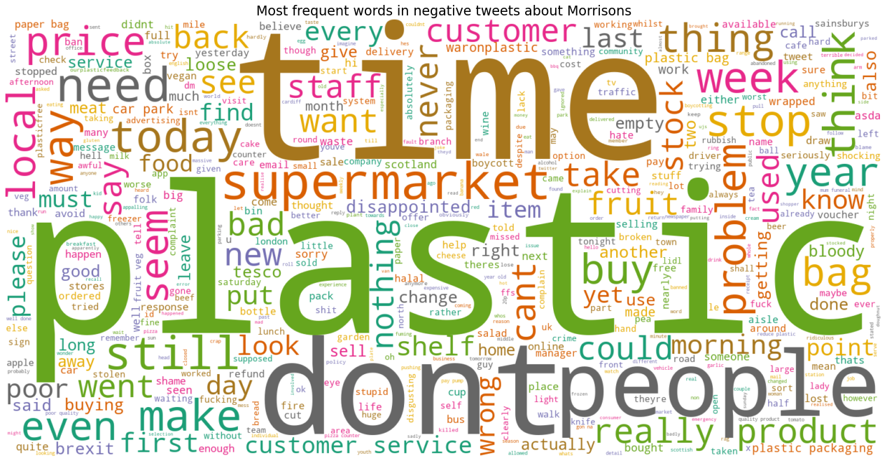

1. **Discussion**

During the process, from collecting the twitter API to initial processing, cleaning and running the NLP analysis algorithm. There are many interesting things to learn about the groceries chains.

First, to answer the research question: can TSA be used to predict the business situation of enterprises? The experimenter had tried to apply both TextBlob and VADER algorithms. The results showed that the VADER algorithm is more accurate, with the use case here being a social networking environment, where users are more likely to use slang, repeat, or misspelled words than the average environment formal text field, which seems more suitable for TextBlob. This study applies to two cases of two supermarket chains, Aldi and Morrisons, because these two chains have relatively close market shares, and are equally competitive in the UK. In terms of total tweet mentions, Aldi had already outnumbered Morrisons (40.606 vs 24,058).

Overall, the TSA results are relatively consistent with the company's business and market share. Specifically, when the rate of negative comments increases, the market share also begins to decrease, and vice versa. Eventually, during the test and trial process, the tweets data needs a 1–2-month delay effect to affect the market share of the business, not immediately. In Aldi case, this delay effect took 1 month. In Morrisons’s case, the delay effect is about 1-2 months.

In detail for case of Aldi, Aldi’s tweet sentiment figures accurately reflect market share, after a month of lag. Regarding the positive comments, this study will not discuss, because they are all general compliments. As for the negative comments, in the first half of 2018, the negative keyword received the most was "time", which decreased significantly in the second half of that year. That shows Aldi has discovered and improved their weaknesses in time. The most notable point with Aldi's case is that the 2018 Christmas marketing campaign has significantly pushed the company's market share up. In every aspect of sentiment, all tweets have the keyword "Christmas", everyone mentioned Aldi and this promotion campaign, making a huge branding effect on social networks. And Aldi is always being compared to Lidl whether positive or negative.

For Morrisons, the figures in 2018 fairly reflect the reality. Morrisons' market share is also cyclical, peaking around January, falling to a low in March, then recovering a bit and lowest around September. As for the reason why Morrisons has lost such market share, it may be because it has been slow to detect and fix shortcomings in its service. This can be seen in negative tweets, throughout the study period, the most commonly repeated keywords remained the same. This proves that customer dissatisfaction has been accumulated for a long time. The keyword that needs most attention with Morrisons is "plastic". In 2019, the TSA data of the first 3 quarters still relatively accurately reflects the market share index. Until the fourth quarter, an unusual thing happened when the company was gradually regaining market share, in November it received the most negative tweets of the year. This was again 2 months lag, leading to a decline in market share in January next year.

The first reason is about the retail industry. With very clear characteristics of customer segment, store location. Each retailer will have a different business strategy. With Aldi, the company's business strategy is clearly on the price factor, so its stores are usually large stores, with a small quantity located outside the city centre, making it less convenient for customers to go shopping. As for Morrisons, this company does not emphasize the price factor, but the store location is similar to Aldi, with a large store located outside the centre. The quality factor will be paid more attention by this company, but it will not be as high as its strong competitors in terms of quality. Perhaps that is the reason why Morrisons' customer file is scattered, not centralized, leading to the company gradually losing market share.

About Behavioural Analytics side:

To sum up, using TSA can somehow predict the trend for the market situation of the business enterprise.

1. **Conclusion**
2. **Conclusion**

TSA can be utilized as a reliable source to predict and caution for the market share of the business. Or simple as businesses could understand what is happening on market with their products. To comprehend the customers’ opinions, whether they like it or what is the problems that need to be review. With fairly reliable results, and more importantly understand the strengths and weaknesses of the business in real time.

For positive reviews, businesses can see where they are doing well, even more specifically in which facilities, factors or specific products. From there, the next special bonus and additional campaigns can be launched.

As for the negative reviews, somewhat is more important to the business. Because from there, they can understand what customers are not satisfied with. They can then make internal assessments, find out the cause and finally come up with a solution to the problem.

1. **Limitations**

This research is still lack of many reliable sources, and as many other causes that are being unaware of could lead to the result.

The first limitation is on the factor of customer habits. For grocery shopping, it is a very normal daily routine for every household. Every family will have a habit of shopping at certain supermarkets mainly based on convenience factors (in terms of location, quality of goods and price). Therefore, it will be difficult for a company to lose or gain more market share, unless that company opens or closes its stores. Therefore, this study lacks the financial leverage factor in the business of each enterprise.

The second limitation is about the tweets factor. Usually for normal routines like grocery shopping, customers rarely tweet about it. Unless something extreme has happened (be it positive or negative). Therefore, aggregated tweets will not fully reflect what customers are really thinking about businesses in the retail industry.

1. **Suggestions and further study**

From here, businesses can use predictive models in real time, on a weekly or monthly basis, to be able to track the actual situation of customer receipts in the 4.0 era. This is when everyone has access to the internet, and the most common means of communication and expressing personal opinions is through social networks, be it Twitter, Facebook or Instagram, etc.

**References**